Project Design Phase
Solution Architecture

Date | 15 February 2025
Team ID
Project Name | RentEase - House Rent Management System
Maximum Marks | 4 Marks

Solution Architecture:
Solution architecture is a complex process – with many sub-processes – that bridges the gap between business problems and technology solutions. Its goals are to:
- Find the best tech solution to solve existing business problems.
- Describe the structure, characteristics, behavior, and other aspects of the software to project stakeholders.
- Define features, development phases, and solution requirements.
- Provide specifications according to which the solution is defined, managed, and delivered.

Example - Solution Architecture Diagram:


Figure 1: Architecture and data flow of the voice patient diary sample application
Reference: https://aws.amazon.com/blogs/industries/voice-applications-in-clinical-research-powered-by-ai-on-aws-part-1-architecture-and-design-considerations/

Our Solution Architecture — RentEase
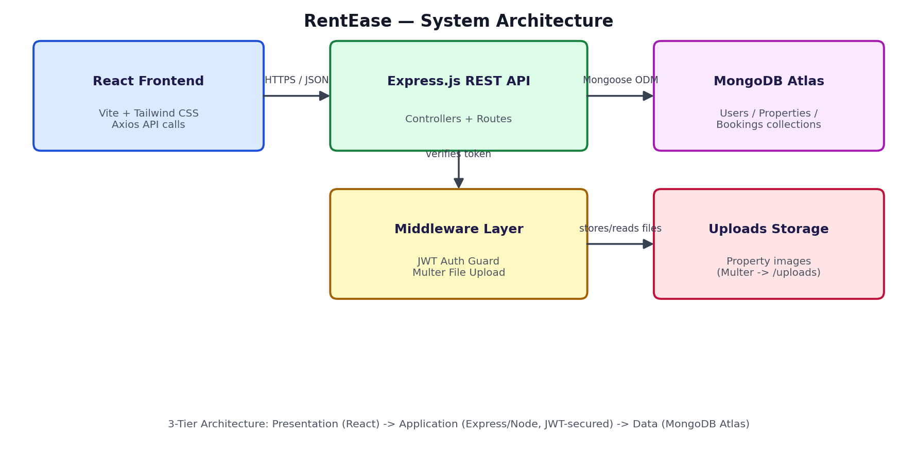
Figure: RentEase 3-tier system architecture (React client, Express/Node REST API with JWT middleware, MongoDB Atlas)
The React frontend (built with Vite and styled with Tailwind CSS) communicates with an Express.js REST API over HTTPS using JSON. Protected routes (property creation/editing, booking approval) pass through a JWT authentication middleware that verifies the tenant/admin role before reaching the controller logic. Mongoose models (User, Property, Booking) persist data to MongoDB Atlas, while property images are handled through Multer and served from the uploads directory.

